How to reconcile an electronic collection in Alma based on a list of available titles provided by the vendor/access provider.

Scenario: There is an electronic collection in Alma. The vendor/access provider removed access to an unknown number of titles. You have a list of titles available for your library.

Goal: Remove bibliographic records and portfolios in Alma for titles we no longer have access to.

Basic procedure:

1. Create a set in Alma of all electronic titles in the electronic collection

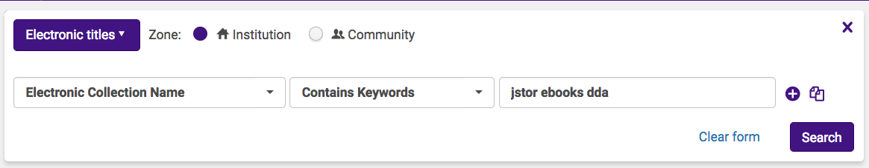

1. Create itemized sets of electronic titles based on identifiers (ISBN's, OCLC numbers) in the title list provided by the vendor, access provider or Worldshare Collection Manager.

<https://knowledge.exlibrisgroup.com/Alma/Product_Documentation/010Alma_Online_Help_(English)/050Administration/070Managing_Jobs/060Managing_Search_Queries_and_Sets#Creating_Itemized_Sets>

* 1. You may have to create multiple sets (the first based on print ISBN, the second based on electronic ISBN, and the third based on OCLC number) because
     1. matching by ISBN is never exact (a title list provided by the vendor may have some print and/or electronic ISBN's, while the bibliographic record may have some print and/or electronic ISBN's, and they may not always match)
     2. You may want to match by OCLC number but some titles may not have one.

1. Then you "combine" the set from step #1 with the set(s) created in step #2 using the NOT operator.

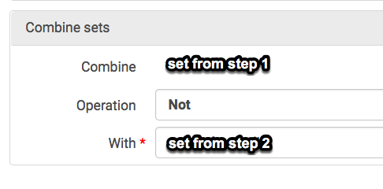

Basically you're starting with the entire collection and excluding titles that are available, like a multi-stage sieve. You may have to run multiple "combine" functions depending on how many sets you created in step #2.

1. I started with the set of all electronic titles in the collection, then combined it using the NOT operator with a set of electronic titles created from *electronic ISBNs*.
2. From the set created in step a, I ran another "NOT combine" using a set of electronic titles created from *print ISBNs*.
3. Then from the set created in step b, I ran another "NOT combine" using a set of electronic titles created from *OCLC numbers*.

[https://knowledge.exlibrisgroup.com/Alma/Product_Documentation/010Alma_Online_Help_(English)/050](https://knowledge.exlibrisgroup.com/Alma/Product_Documentation/010Alma_Online_Help_(English)/050Administration/070Managing_Jobs/060Managing_Search_Queries_and_Sets#Combining_Sets)

[Administration/070Managing_Jobs/060Managing_Search_Queries_and_Sets#Combining_Sets](https://knowledge.exlibrisgroup.com/Alma/Product_Documentation/010Alma_Online_Help_(English)/050Administration/070Managing_Jobs/060Managing_Search_Queries_and_Sets#Combining_Sets)

1. After step #3 you should end up with a set of electronic titles that you do not have access to.
   1. You may randomly spot-check titles in the set to confirm that they are not accessible.
   2. Finally, you delete the inaccessible portfolios and then the corresponding bib records using manual jobs.

[https://knowledge.exlibrisgroup.com/Alma/Product_Documentation/010Alma_Online_Help_(English)/050](https://knowledge.exlibrisgroup.com/Alma/Product_Documentation/010Alma_Online_Help_(English)/050Administration/070Managing_Jobs/020Running_Manual_Jobs_on_Defined_Sets)

[Administration/070Managing_Jobs/020Running_Manual_Jobs_on_Defined_Sets](https://knowledge.exlibrisgroup.com/Alma/Product_Documentation/010Alma_Online_Help_(English)/050Administration/070Managing_Jobs/020Running_Manual_Jobs_on_Defined_Sets)